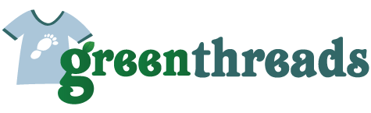

Jeffers Hill Elementary School

Clothing Drive Fundraiser

Clothing Drop-off Dates: April 23th-May 3rd

Step by Step Instuctions:
- Spring clean your closets
- Place unwanted clothing, accessories, household items, stuffed animals in a plastic garbage bag.
- Drop off at JHES between drop-off dates.
- Accept our thanks for helping JHES.

Accepted items:

Men’s, Women’s, & Children’s clothing & Shoes

Accessories such as: scarves, ties, belts, wallets, & handbags

Household items: blankets, sheets, towels, & tablecloths

Stuff animals & plush toys
There are lots of ways to generate money for your school, but very few require no out-of-pocket expense. A Green Threads clothing drive will help us meet the fundraising goals without having to spend a dime. It’s also a great way to teach students about the importance of recycling and raise awareness about environmental issues.
Questions call the front office at 410-313-6872.

Green Threads Recycling good condition items….

Promoting better condition communities…

